Learning Issues Research Project
Change just one thing

Please bring along a fully charged laptop or digital device and login to the resource page for today's session: https://ccqi.org.uk/resources/bc-digital-research-project

Learning Outcomes
By the end of the session, delegates will be able to:

- Identify the learning issue they would most like to resolve.
- Use the Common Learning Issues resource to plan a Research Lesson.

Task 1: Learning Issues
If you could wave a magic wand and instantly resolve one of the learning issues you face day in day out, what would you choose? What costs you the most time and effort?

Task 2: Long list of possible research themes
Tick the menu item (issue) that most closely resembles what you've set down in task 1.

Aspirational outlook
Barriers to independent learning
Behaviour issues
Concentration and engagement
Critical reflection
Differentiation
Don’t understand
Homework
Late assignments
Learning outcomes
Lesson openings
Maths
Motivation
Note taking
Passivity – use of Q&A
Punctuality
Project management
Social relationships
Spelling
Study skills
Transition point management
Vocabulary (1) personal expression
Vocabulary (2) terminology

Task 3: Research Lesson

Lesson title
[Choose a lesson in which you could experiment with a strategy you haven't used before.]

Issue you'd like resolved

- Passivity

Learning outcomes
[These should set out how you want learners to be 'different' by the end of the lesson, not a 'to-do' list of activities.]

The strategy from the database with which you'd like to experiment

What are the implications for your lesson design and the investment you would have to make?

If the experiment works, what difference would you hope to see in your learners?

Task 4: Research Lesson

Lesson title
[Choose a lesson in which you could experiment with a strategy you haven't used before.]

Issue you'd like resolved
[The issue heading from the database.]

Learning outcomes
[These should set out how you want learners to be 'different' by the end of the lesson, not a 'to-do' list of activities.]

The strategy from the database with which you'd like to experiment

What are the implications for your lesson design and the investment you would have to make?

If the experiment works, what difference would you hope to see in your learners?

Review notes
Please feel free to build your review notes as we go through the session. As this is very much a draft version of the final resource, your thoughts could greatly influence the final version.

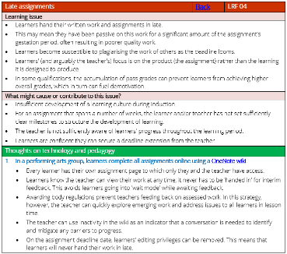
What do you think about the format of each section:

- The issue heading
- A description of the issue
- Actions that might cause or contribute to the issue
- Possible solutions: Thoughts on technology & pedagogy

Do you prefer:

- Menu 1 (headings only)
- Menu 2 (with description)
- Both
- Other – please suggest what terms you would like to search on.

What do you feel about this overall approach?

What improvements would you like made to the resource?

Any further comments?

