Version 05 7/2/22
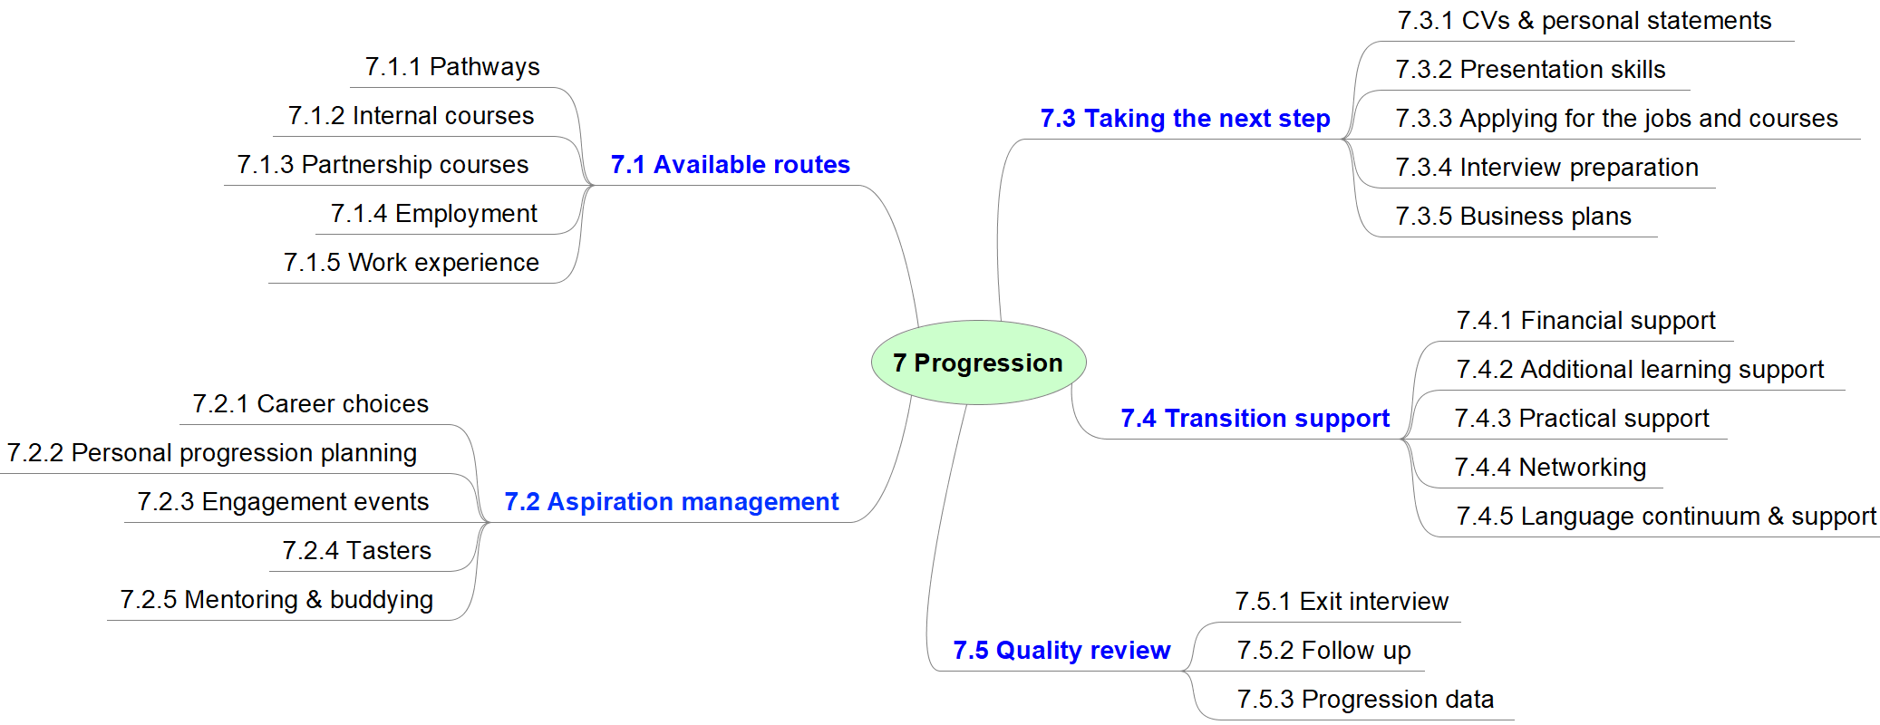
 | Area | 7 Progression
Aspect |  | Elements | Gold Standard intended impact:
7.1  Available routes |  | 7.1.1  Pathways | The common values and vocabulary of all partners ensures learners can easily explore draft versions of their future self, within and outside of the partnerships' offer.
 |  | 7.1.2  Internal courses | Learners use their understanding of internal progression routes and learner support services to build coherent learning journeys to help meet their ultimate aspirations. In some instances, this may include progression to more appropriate vocational choices of the same educational level.
 |  | 7.1.3  Partnership courses | Provider staff use their understanding of wider partnership provision to ensure learners (and themselves) build coherent learning journeys to help meet their ultimate aspirations.
 |  | 7.1.4  Employment | Provider staff ensure that learners' understand how courses link to future paid and unpaid employment opportunities. This understanding, and awareness of available support, drives learners' commitment to their studies.
 |  | 7.1.5  Work experience | The experiences learners undertake during their courses, which may include work experience and workplace visits, ensure they can set out draft versions of their future lives.
7.2  Aspiration management |  | 7.2.1  Career choices | While learners may feel their next step will take them outside of their comfort zone, they are confident that the effective preparation for progression will ensure their success.
 |  | 7.2.2  Personal progression planning | Learners develop effective project-management skills and use these to set and manage targets that drive forward their learning projects and the completion of their course.
 |  | 7.2.3  Engagement events | Wherever appropriate to a learner's progression aspirations, learners attend the partnership's clearly signposted series of guest lectures, employer visits, coffee mornings and/or other engagement events.
 |  | 7.2.4  Tasters | Where learners are unsure of their onward vocational choices, they use taster sessions and 'have-a-go experiences' to make their decisions. These taster sessions offer learners a true and accurate experience of what they can expect from future courses and what is expected of them.
 |  | 7.2.5  Mentoring & buddying | Learners in need of support use the available mentoring and/or buddying to achieve their goals. These approaches build learners' confidence to support each other, to seek support from other professionals when required, and to ensure transition is issue-free.
7.3  Taking the next step |  | 7.3.1  CVs & personal statements | Learners draw on the experiential learning at the heart of their courses when completing their CVs and personal statements. The effective development of their communication skills ensure they express themselves effectively.
 |  | 7.3.2  Presentations skills | Learners present themselves confidently and communicate ideas, information and messages effectively.
 |  | 7.3.3  Applying for the jobs and courses | Learners have the skills to apply for the role or course of their choice.  Pre- and post-course information, advice and guidance includes: Labour Market Intelligence (LMI), links with Careers Advisors, relevant job-search information, and the available multi-agency support services as well as natural progression courses. Learners use this information effectively to secure appropriate job or course interviews.
 |  | 7.3.4  Interview preparation | Learners are excited by the opportunity to sell themselves at interview and are prepared well.
7.4  Transition support |  | 7.4.1  Financial support | Financial concerns are not a barrier to progression. Where needed, learners access appropriate financial support to progress to their chosen course. Learners full understand the implications of their choices ensures they commit wholeheartedly to their chosen path.
 |  | 7.4.2  Additional learning support | Learners with additional learning support needs are excited about their chosen progression option and are confident that the proposed barrier-mitigation strategies will support their transition effectively.
 |  | 7.4.3  Practical support | Provider staff effectively identify and mitigate any potential practical barriers to learners progressing to the next step.
 |  | 7.4.4  Networking | Learners understand the value of mutual peer support and use their peer network to ask for help when needed and offer support when asked.  Learners proactively build a network outside of/in addition to their course peers to open up opportunities for progression.
 |  | 7.4.5  Language continuum & support | The flowing continuum of post-compulsory education facilitates increased rates of progression. This is underpinned by continual bilingual opportunities and support for learners – of all levels – that develops their confidence to use the Welsh language in both social and vocational contexts.
7.5  Quality review |  | 7.5.1  Exit interview | Exit interviews enable providers to understand the impact of provision on learners, including the elements of provision that have enabled learners to progress and elements that learners feel should be reviewed. This information is used to inform on-going curriculum design.
 |  | 7.5.2  Follow up | After leaving and having sufficient time to reflect, learners provide constructive reflections on the strengths and areas for improvement of their experience.
 |  | 7.5.3  Progression data | Progression data, whether to jobs, courses or volunteering, is used to self assess the effectiveness of curriculum design and support services, and to make timely improvements to provision.

