Version 05 7/02/22
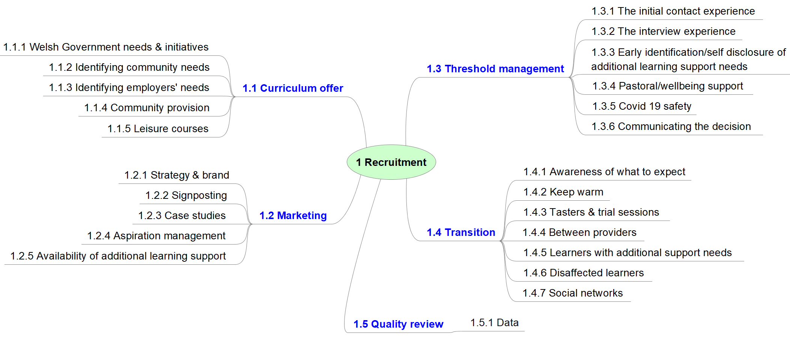

 | Area | 1 Recruitment
Aspect |  | Elements | Gold Standard intended impact:
1.1  Curriculum offer |  | 1.1.1  Welsh Government needs & initiatives | The Partnership's thorough community- and employer-focused curriculum planning meets all of the requirements of the Welsh Government's remit letter, national priorities and related initiatives.
 |  | 1.1.2  Identifying community needs | The Partnership's local and regional needs analysis ensures coordinated curriculum planning meets all viable needs and language continuum for all learners. The register of un-met course requests continually informs individual and group needs within the community resulting in viable new provision wherever possible. Employers not only see clearly how their skills needs are met in the course offer, but also how the curriculum available can further grow their businesses.
 |  | 1.1.3  Identifying employers' needs | Curriculum planning is linked clearly to labour market intelligence, to ensure there are viable opportunities to meet employers' skills needs .
 |  | 1.1.4  Community provision | All sections of the public, for whom community provision can add value, access courses they are confident will improve their skills, health and wellbeing, cultural and social engagement and/or integration.  Prospective learners easily understand course content, the meaningful progression pathways available, and the choice of online, blended and face-to-face delivery options. Learners use this understanding to make informed decisions to which they commit wholeheartedly.
 |  | 1.1.5  Leisure courses | The effective sign-posting of leisure courses engages learners in initial learning, from which they progress onto courses that improve skills and employability.
1.2  Marketing |  | 1.2.1  Strategy & brand | Through collaborative working between partners, prospective learners are presented with strongly identifiable bilingual education brands from which to choose. The Partnership-wide bilingual marketing strategy ensures prospective learners can make fully informed choices between the brands and courses on offer, as well as their modes and medium of delivery.
 |  | 1.2.2  Signposting | Comprehensive analysis of community hubs (including, GP practices, schools, health boards, employers, job centres, etc.) ensures all potential learners see clear, accurate and stimulating information about personal, community and language development through training.  Parents/Carers and learners will use their understanding of the linguistic outcomes of the various models of provision to make informed choices about education pathways including an understanding and appreciation of the relevance of the Welsh language and bilingualism to everyday life and to the workplace.
 |  | 1.2.3  Case studies | Bilingual case studies are shared across the partnership and used to inspire potential learners to apply. These help learners understand where the course they are applying for can take them, and how they will be different as a result of their studies.
 |  | 1.2.4  Aspiration management | The partnership's marketing enables prospective learners to create a vision of their future self; to understand how they could be different as a result of engaging in provision. For instance:  - bilingual case studies shared across the partnership inspire potential learners to apply by creating role models whose journeys they might emulate  - lists of progression possibilities enable learners to envision a setting for their future self, whether as a volunteer, in related employment or higher level courses, and how, in the real world, they'll be able to apply the skills they learn  - painting a compelling narrative around peer support and support services enables learners to be confident about future wellbeing and mental health  - information about Social engagement, such as learner networks, clubs and groups, events, social media interaction, excites learners to seek wider social and cultural integration.
 |  | 1.2.5  Availability of additional support needs | Learners' understanding of the learning support and assistive technology available gives them confidence that they could succeed, and so the confidence to apply.
1.3  Threshold management |  | 1.3.1  The initial contact experience | Provider staff responsible for learners' initial contact experience will use their awareness of the potential brittle confidence of prospective learners to provide a sensitive, welcoming and flexible experience that results in progression to the next step.
 |  | 1.3.2  The interview experience | Potential learners look forward to meeting provider representatives to discuss options for study, whether in person or online. As a result of feeling welcomed, valued and cared for, all learners make an informed choice about the most appropriate course to study, and go on to enrol.
 |  | 1.3.3  Early identification/self disclosure of additional learning support needs | Learners volunteer information about any potential barriers they may have to learning and progression without fear of stigma or rejection, and in full knowledge that any support offered will help them mitigate their barriers to independent learning.  Through informal initial assessment processes, learners who are unaware of potential barriers will be assessed sensitively and offered further diagnostic assessment and/or the support they need to mitigate their barriers to independence. Learners eagerly accept the next steps offered.
 |  | 1.3.4  Pastoral/wellbeing support | Learners' understanding of the pastoral support available gives them confidence that they could succeed, and so the confidence to take the next step.
 |  | 1.3.5  Covid 19 safety | Learners are aware of Covid 19 procedures and will feel safe when attending in person. Learners understand the necessity of using online learning as a fall-back strategy due to Government safety announcements, and work with provider staff to mitigate any impact on their studies.
 |  | 1.3.6  Communicating the decision | Learners feel emboldened by being accepted on to their chosen course and excited by the prospect of their first session. Learners who apply for courses that are deemed unsuitable are equally excited about the alternatives offered and relieved that they avoided an inappropriate choice.
1.4  Transition |  | 1.4.1  Awareness of what to expect | Through the use of videos, tours, websites and interviews, potential learners are clear about the experience ahead of them – including the implications of their commitment. These expectations are confirmed through their early experience on the course.
 |  | 1.4.2  Keep warm | The enthusiasm for study created by marketing, the staff responsible for first contact, and interviewers is maintained in the intervening period up to enrolment and the first lesson, resulting in no unexplained dropout.
 |  | 1.4.3  Tasters & trial sessions | Where appropriate, taster experiences and/or courses inspire students to commit to a longer and/or wider programme of study.
 |  | 1.4.4  Between providers | The clarity and common vocabulary of all partners' literature ensures potential learners see and value brand differences and make informed choices. Progression between partners courses is a seamless experience.
 |  | 1.4.5  Learners with additional learning support needs | Potential learners with additional learning support needs apply with confidence, knowing their support needs will be met during the application process and while on course.
 |  | 1.4.6  Disaffected learners | Learners with a poor prior experience of education re-engage with study and commit wholeheartedly to improving their skills, wellbeing and progression opportunities. Their understanding of the development of their independent learning skills fuels their progression through, where appropriate, a series of courses and into employment.
 |  | 1.4.7  Social networks | Take up and celebration of these courses through social networks continually builds a sense of community, an appreciation of culture and of learning. This in turn inspires others to take part as they realise that success – and the realising of personal ambition – is locally achievable.
1.5  Quality  review |  | 1.5.1  Data | All providers collect data that tracks learners through the recruitment process, enabling them to quickly identify any areas for improvement. Data includes:  - Enquiries to application;  - Applications to interview  - Interviews to enrolment

