Progress Reviews
The project management of a learner's journey.

Version 06 1/04/22
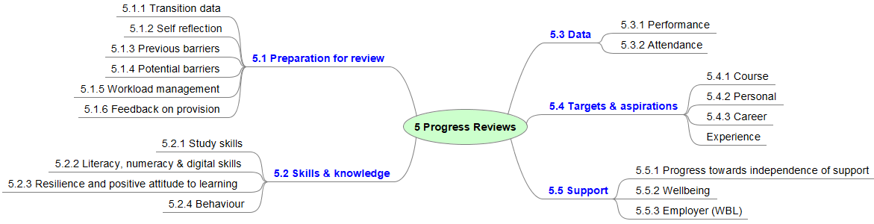
 | Area | 5 Progress Reviews
Aspect |  | Elements | Gold Standard intended impact:
5.1  Preparation for review |  | 5.1.1 Transition data | Comprehensive data from outside agencies and partners provide learners with insight into the support they may require to be successful at college.
 |  | 5.1.2 Self reflection | By preparing effectively for their reviews, learners lead on discussions about their progress and attainment and feel inspired and in control of their learning journey.
 |  | 5.1.3 Previous barriers | Learners critically reflect on any barriers they have encountered and the effectiveness of their mitigation strategies.
 |  | 5.1.4 Potential barriers | Learners identify potential barriers ahead of the next review and set out mitigation strategies and access relevant support.
 |  | 5.1.5 Workload management | Learners use their understanding of course expectations to identify what success for them will look like. In preparation for each review, learners evaluate the effectiveness of their workload management skills in achieving their vision.
 |  | 5.1.6 Feedback on provision | Learners reflect on their own engagement with support provision to achieve well, and present constructive suggestions for improvement where appropriate.
5.2  Skills, knowledge & Attitude |  | 5.2.1 Study skills | Learners use independent learning skills to enable them to exceed expectations on all activities.
 |  | 5.2.2 Literacy, numeracy & digital skills | Learners understand any challenges they face with literacy, numeracy and digital skills and work incrementally to develop these skills. Learners apply skills competently within their subject area at the appropriate level to prepare them for employment or further study.
 |  | 5.2.3 Resilience and positive attitude to learning | Learners feel supported and motivated to attend College and demonstrate a strong work ethic. Learners recognise any drops in learning momentum and have a range of strategies on which to draw to work through their resilience challenges.
 |  | 5.2.4 Behaviour | Learners are aware of and adhering to the Learner code of conduct and use their understanding of fairness, equality and tolerance to guide their behaviour and encourage appropriate conduct from others.

5.3  Data | 5.3.1 Performance | Comprehensive data on course performance provides learners with comprehensive feedback on their progress. Learners use these data to inform future course performance and make improvements.
 | 5.3.2 Attendance | Learners are motivated to maintain full attendance and good time keeping and understand the impact this can have on their learning.
5.4  Targets & aspirations | 5.4.1 Course | Learners are pro-active and skilled in setting their own clear targets to develop their strengths and overcome weaker areas.
 | 5.4.2 Personal | Learners are pro-active and skilled in setting their own clear targets to develop their own goals for personal growth and to develop wider interests.
 | 5.4.3 Career | The setting out of informed career aspirations inspires learners to commit wholeheartedly to their studies and reach their full potential.
 | 5.4.4 Experience | Learners are proactive in planning and benefitting from valuable experiences, whether these be around independent interests, work-related activity or volunteering and reflect on these experiences when considering their future plans.
5.5  Support | 5.5.1 Progress towards independence of support | Learners feel confident to access additional learning support and understand how this will enable them to learn independently. Learners, teachers and support workers understand the discrete barriers to independence and continually monitor the effectiveness of support arrangements, and progress towards the celebration of independence of support (wherever possible).
 | 5.5.2 Wellbeing | Learners feel safe and socially integrated into their learning environment and feel confident to access support when needed.
 | 5.5.3 Employer (WBL) | Where appropriate, the learners respond to feedback from their work-place supervisors.  Learners and tutors are fully aware of work-related attainment and use this to influence target setting.

