Perfecting development-plan writing

Navigate to the following webpage in preparation for the session:
https://ccqi.org.uk/resources/perfecting-development-plan-writing
Password: pdpw1773

Using Zoom

Cameras on
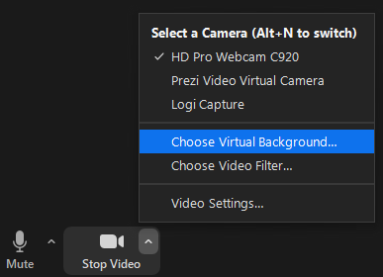
This is a cameras on session using Zoom. Feel free to use a 'virtual background' if you would prefer not to share your surroundings. To turn on a virtual background, click on the '^' symbol to the right of the video camera icon (bottom left corner), then click on 'Choose Virtual Background'. Next, click on 'Backgrounds and Filters' and select a background. You may be asked to download the 'Smart virtual package'. (If you are using an older version of Windows, you may need to click the '+' sign (circling in red) and add your own image.)
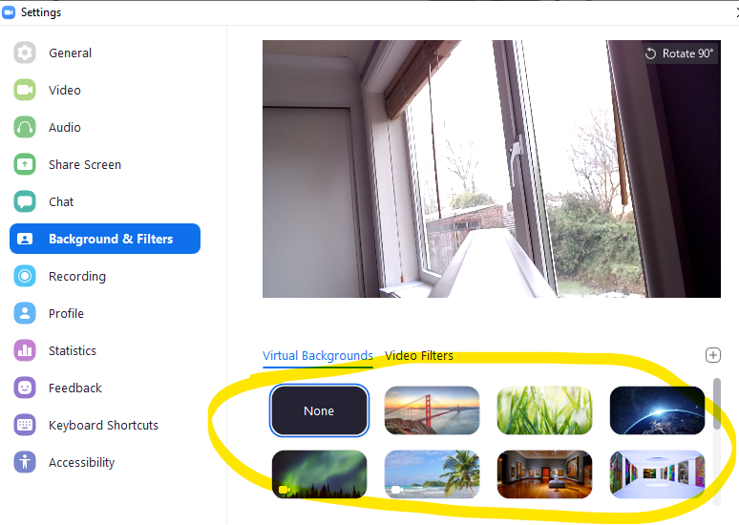

Your name
Please ensure you type the name you wish the host to use when referring to you. To do this, hover over the video image of yourself and click on the three dots that appear in the top right-hand corner. Then select 'Rename'.

Breakout rooms
While in a breakout room, if you'd like to ask a question, please click 'More' and then 'Ask for help'.


Useful Zoom quick keys
Alt + y Raise your hand
Alt + a Mute/unmute audio
Spacebar Temporarily unmute

Development planning issues
The four main reasons that a development plan may not lead to the expected quality improvement.

- Keeping to the width of an A4 page
- Failing to start each line with a crisp issue
- Using end-of-year measures as targets for success
- Failing to project manage the resolution of the issue.

What are the indicators that suggest a learner may not achieve on time?

What are the indicators of disengagement?

Why might a learner find it difficult to concentrate?

Choose one of the issues from the whiteboard and write it below:

In your breakout groups, ask 'why' as many times as it takes to get to what you consider to be the root-cause issue. The rule is that you must 'own' the final issue; you cannot put it on someone else's development plan.

Write your final root-cause issue below:

Research task and break
Explored your own development plan
Write an 'S' (Symptom) or an 'I' (Issue) against each row. This will tell you whether you're trying to resolve adverse symptoms or whether you've carefully identified the root-cause issues.

Choose one symptom you would like to take forward into the writing exercise and write it below:

A Root-cause issue
What do you feel is the root-cause issue for your chosen adverse symptom?


'The walk across the carpet'

B The vision of success (Target)
What is the ideal difference you want to make to learners? Imagine you have a time machine and you've travelled forward to the point at which the issue is now resolved. What do you now see? Keep your statement as close as possible to the issue you're trying to resolve.

C Indicators
'How will you know' that you have achieved the resolution of your issue? What indicators will tell you?


What implication do these 'indicators' have on SMART target writing?

Silent Minute

D Actions

Further considerations
- Should you use column headings that are about 'accountability' (which make the system architect feel good) or those that allow kudos to be deservedly owned by whomever is doing the improvement work? Consider replacing 'Responsibility' with 'Champion'.
- Should you dislocate the project management of issue resolution from the development plan by keeping actions in meeting minutes instead of the form itself?
- Can you see value in reflecting on what has and hasn't worked when working to resolve an issue?
- What impact do you feel the 'Celebration File' strategy would have on teams' and individuals' morale?
- Do you feel a traditional development plan format – with one row across an A4 page – is appropriate?
- Are you clear about the damage that can be caused by jumping to 'actions' too early in the process?

Curriculum Area:

Academic year:

 | Area: |  |  |  | Last review date: |  |  |  |  | Next review date:
Issue |  | Intention – What is our intended impact?
 |  | What indicators can we use to measure early progress and show we’ve resolved the issue? |  |  |  |  |  |  | Milestone |  |  |  | Target |  |  | Achieved
 |  |  |  |  |  |  |  |  |  |  | Date |  |  |  | Date
 |  | Action – What are we going to do to achieve our intended impact? |  |  |  | Champion (Bld)  & team (Ita) |  | What should we have done and where should we be by the next review date? |  |  |  |  |  |  |  | Diary date/s
 |  | 1
 |  | 2
 |  | 3
 |  | 4
 | Progress | 1 | Date | Progress to date
 | Progress | 2 | Date | Progress to date
 | Progress | 3 | Date | Progress to date
 | Progress | 4 | Date | Progress to date

Cost & resources (if significant):

Curriculum Area: Music Academic year: 2015
 | Area: | Recruitment |  |  | Last review date: |  |  |  |  | Next review date:
Issue |  | Intention – What is our intended impact?
1.7  Ineffective support strategy between interview and enrolment for music learners to achieve grade 1 music theory on entry |  | All learners will commit enthusiastically at interview to achieving the entry requirements for their chosen course. They will feel supported and confident in the support strategy provided and achieve the conditional entry requirements. Learners will feel an added bond with the college due to its pre-course investment in them.
 |  | What indicators can we use to measure early progress and show we’ve resolved the issue? |  |  |  |  |  |  | Milestone |  |  |  | Target |  |  | Achieved
 |  |  |  |  |  |  |  |  |  |  | Date |  |  |  | Date
 |  | Learner feedback at interview, throughout the pre-entry phase and at enrolment |  |  |  |  |  |  |  |  |  |  | Exc’t
 |  | Clear offers and support strategies where required
 |  | Accessing of support strategy as set out in plan |  |  |  |  |  |  |  |  |  |  | 100%
 |  | Achievement of entry requirements |  |  |  |  |  |  |  |  |  |  | 100%
 |  | Action – What are we going to do to achieve our intended impact? |  |  |  | Champion (Bld)  & team (Ita) |  | What should we have done and where should we be by the next review date? |  |  |  |  |  |  |  | Diary date/s
 |  | 1 | Sell the benefits of being able to speak the language of musicians and underline the positive impacts on their ability to progress on the course.
 |  | 2 | Provide the study resources needed to achieve grade 1 theory (including loan copy of theory book and practise papers).
 |  | 3 | Provide a 1:1 or group set-off session to ensure applicants know how to use the resources.
 |  | 4 | Provide email and drop-in support to existing college theory sessions and/or short additional sessions during the summer break.
 | Progress | 1 | Date | Progress to date
 | Progress | 2 | Date | Progress to date
 | Progress | 3 | Date | Progress to date
 | Progress | 4 | Date | Progress to date

Cost & resources (if significant):

Next steps
Jot down your immediate thoughts about what you might ideally want to do differently, if anything.

Aspect you'd like to change | The change you'd like to make

Self-Assessment online training sessions
- Perfecting self-assessment writing
- Perfecting development plan writing & The Data Springboard
- Introduction to the CCQI Self-Assessment Strategy
- Using the CCQI Self-Assessment Strategy

Please see www.ccqi.org.uk/consultancy-support/live-self-assessment for more details.

Session resources
All of the resources to support this session can be found on the Centre for Creative Quality Improvement website:

https://ccqi.org.uk/resources/perfecting-development-plan-writing

To access the resources you will need the following password: pdpw1773

