Inspiring Induction Practice

Preston College Conference

Navigate to the following webpage in preparation for the session:
https://ccqi.org.uk/resources/inspiring-induction-practice-preston-college-conference

This session will enable delegates to:
- produce an aspirational Quality Standard for Induction
- explore the Formula for Optimal Flow and explore its impact on the production of schemes of work and lesson plans for the extended induction period
- prepare for inspection by considering the implications of the new Ofsted Education Inspection Framework with its focus on Intent and Implementation.

Silent minute
How good is your learner induction experience?

To be able to judge your effectiveness, you must first ask:

- How do I want learners to be different as a result of their induction experience?
- What impact do I want to have on them?

The Learner’s Journey

- Recruitment
- Induction
- Teaching, learning and assessment
- Support
- Progress monitoring
- Achievement
- Progression

The Quality Standard Taxonomy
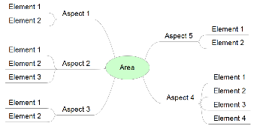
The Quality Standard Taxonomy has three tiers:

- Area
  - Aspects
  - Aspects
    - Elements
    - Elements

This taxonomy approach enables us to define every element of a job role. However, it should be noted that the Quality Standard is an aspirational document that sets out what outstanding provision would look like in your organisation, rather than simply a slavish account of current practice.

Areas
The key headings that define a whole job role.

Whether teachers, support staff, managers or governors, arguably every job role can be encapsulated in a short list of headings, or areas. For instance, for the teaching role this is arguably best seen as the seven steps of the learner’s journey:

- Recruitment  - Induction  - Teaching, learning and assessment  - Learner support | - Progress monitoring  - Achievement  - Progression

Aspects
The key themes that need to be explored within each area of provision.

Within each area of work, aspect headings are used to pull together the detail as efficiently as possible. For instance, within the Induction step of the learner’s journey, the aspect headings might include:

- Initial assessment
- The expert learner
- Equality, diversity and safeguarding
- etc.

Additional aspect may include:

- Induction of late enrollers | - International learners

Elements
A word or short phrase that identifies an intended impact or a process to produce an intended impact.

Element headings are perhaps the most elusive to define. Each element heading will lead to the writing of a Gold Standard Impact statement, so it is important to be economical and avoid duplication or detail on how the impact might be achieved. For instance, in the example below, consider the difference between the following element:

- group development

and the possible actions to produce the intended impact:

- welcome events
- ice breakers
- trips and visits
- tournaments.

Aspect | Area | Element | Impact | Actions
Induction | Social bonding | Group development | Learners are at ease and form constructive working relationships with all peers. Social bonds are strong and an additional motivator for attendance. | - Welcome events  - Ice breakers  - Trips and visits  - Tournaments  - Etc.

Each one of the action headings might well meet the definition of an element:

- A word or short phrase that identifies an intended impact or a process to produce an intended impact.

However, it can be seen that by looking forward to how the intended impact might be written for each of these actions that there would be considerable duplication, which is to be avoided wherever possible.

NB. Keep the level of ambition for your intended impact relevant to the area under consideration. For example, ‘The Expert Learner’ may be an aspect of both the Induction and Teaching and Learning areas, but the ambition for your impact would be very different in the, say, six-week induction period and a full two-year programme of study.

Quality Standard

Task 1
Through discussion, arrive at what you consider to be the key Aspects of Induction. Add these below.

Task 2
Spokespeople, add your Aspect headings to the Jamboard, but don't duplicate entries.

Induction

Task 3
On this mindmap, underline the Aspect headings (on the Jamboard make them blue) and arrange Element headings beneath them.
Area | 2. Induction
Aspect | Elements | Gold Standard intended impact:
2.1  Expert learner | 2.1.1  Critical reflection skills | Learners' understanding of quality is inline with teachers' and awarding body expectations. Learners use this understanding to critically reflect on their work as it develops and use a range of editing techniques to ensure it meets their own high expectations before submitting it for scrutiny.

Gold Standard impact text
Write 'active' text. Avoid:
- learners have access to
- learners are enabled to
- learners have the opportunity to

Set out what learners 'do':
- learners [verb]

Examples
Induction
- Goal setting > Career aspiration management
  - Learners make informed choices about their next steps and are inspired to work towards a clear goal or a narrow range of options.
- Barrier identification > Potential barriers to learning
  - Learners are clear about the potential barriers to their learning progress in the short and medium term (including ALS) and mitigate them with effective strategies.

Task 4
- Choose an Element heading from the Jamboard.
- Claim the Element by changing the text colour to red.
- In the wiki, claim a row by adding your initials to column 2.
- Then type in the Aspect and Element headings you're going to work on, and finally write the impact text for it in column 5.

NB. There's space to work out your text below.

Area | 2. Induction
Aspect | Elements | Gold Standard intended impact:

The Formula for Optimal Flow

- Flow comes from control.
- Control requires rules and the learning of new skills.
- The learning must be goal orientated and provide feedback.

In short: a goal-directed, rule-bound action system that provides clear clues as to how well one is performing.

In detail
- Enjoyment normally occurs when we confront tasks we have a chance of completing.
- We must be able to concentrate on what we are doing.
- Concentration is usually possible because the task has clear goals, and
- provides immediate feedback.
- One acts with a deep but effortless involvement that removes from awareness the worries and frustrations of everyday life.
- Enjoyable experiences allow people to exercise a sense of control over their actions.
- Concern for the self disappears, yet paradoxically the sense of self emerges stronger after the experience is over.
- The sense of the duration of time is altered; hours pass by in minutes, and minutes can stretch out to seem like hours.

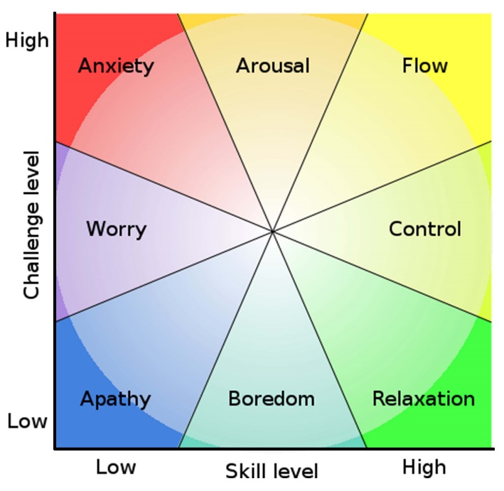
Mihaly Csikszentmihalyi (1990) Flow: the psychology of optimal experience. New York: HarperPerennial

[For more information on using the formula, visit www.ccqi.org.uk and search for ‘HoT2’]

Task 5 – The Induction ‘Zone’ Experience

Your task is to choose one or more Quality Standard impact statements as the starting point for an immersive new online induction experience that gets your learners into the zone. Here are the rules:

- Even if it’s online, it must be collaborative.
- It must achieve one or more of the elements in the Induction Quality Standard.
- Think huge, a caricature of what might be considered normal practice.
- Money is no object, I’m giving you a blank cheque.
- You’re even allowed to break the laws of physics. You want a time machine? It’s yours. This means that your initial ideas are not allowed to be held back by any pragmatic considerations.
- Make yourselves laugh with your ideas.

You may wish to use these headings to help structure your emerging ideas.

The intended impact on learners will be: [Taken from the Quality Standard]

I’ll know if I’ve achieved my intended impact if… (state measurables – what will you see?)

To make this huge idea a reality I would have to…

To get the ball rolling by next week, I need to…

I aim to have fully developed my idea by: (date)

My huge idea is:

